ITEC31041 – Mobile Platform applications
Name: TOBENNA NWAFOR Student ID: N1205091

App proposal and impact
NTU HUNT APP

Background Context
University campuses are often vast, complex environments filled with diverse facilities, buildings, and services. Navigating this space can feel overwhelming, especially for new students that are adjusting to academic and social life. The sheer scale and unfamiliarity of the campus can discourage exploration, leading many students to stick to the most direct and familiar routes between lecture halls, dormitories, and cafeterias without ever detouring.
Once these routines are established, students rarely deviate from them, which means large parts of the campus remain undiscovered throughout their entire course. This lack of exploration results in missed opportunities to discover hidden resources, social spaces, and recreational facilities that could enrich their university experience.
Due to such, many students remain unaware of valuable facilities such as libraries, study hubs, counseling services, and sports complexes. Campus events, clubs, and societies may also be overlooked if students are not actively engaging in different areas. This reduces the richness of the university experience and limits personal growth outside of academics.
Ultimately, lack of exploration can contribute to isolation, reduced physical activity, and weaker connections to the wider student community. Students may graduate without ever experiencing the entirety of opportunities their campus provides. This does not only affect individual wellbeing but also diminishes the richness of campus culture as a whole.
App Proposal
The NTU Hunt app is a GPS-based treasure hunt platform designed to gamify exploration of Nottingham Trent University’s campuses. By turning the campus into an interactive playground, the app encourages students to discover facilities, health competition amongst friends, and engage in healthy physical activity. Students can participate in hunts individually or as part of a team, fostering collaboration, communication, and friendly competition. Each hunt is guided by real-time GPS navigation, with themed challenges such as “Library Quest,” “Sports Challenge,” or “Hidden History of NTU” that highlight different aspects of campus life.
To keep students motivated, NTU Hunt incorporates a rewards system that offers points, badges, and leaderboard rankings. These achievements create a sense of recognition and excitement. Rewards may even extend to tangible benefits such as discounts at campus cafes or perks from student societies. Departments and student organizations can design their own hunts to promote events or resources, making the app a flexible tool for engagement. Accessibility is also a priority, with routes tailored for students with mobility needs and alternative challenges available indoors where GPS accuracy is limited.
Gameplay flows naturally as students navigate to locations, unlock achievements, and earn badges. Looking ahead, NTU Hunt has strong potential for expansion. It could be extended across NTU campuses integrated into career fairs or alumni events and enhanced with augmented reality features that overlay digital clues on real-world locations. The app could also provide anonymized engagement data to NTU staff, offering insights into how students interact with campus spaces. With opportunities for partnerships and sponsored hunts, NTU Hunt is positioned not just as a game, but as a powerful student engagement tool that strengthens community bonds, promotes wellbeing, and ensures students fully experience the richness of university life.
Market Research Findings
- High Levels of Student Loneliness & Disconnection
  - A recent report highlights that 60% of students feel lonely and disconnected from campus life, with institutions struggling to rebuild engagement after the pandemic.
  - This indicates a clear need for tools that foster community interaction and belonging, which NTU Hunt directly addresses through team hunts and gamified exploration.
- Demand for Gamification in Higher Education
  - Gamification is increasingly recognized as a powerful way to boost student motivation, collaboration, and participation. Universities that integrate game-like elements into learning and campus life see higher engagement rates.
  - Research shows that students respond positively to competitive and playful experiences, which fuel participation and drive action.
- Technology Expectations of Modern Learners
  - Today’s students expect personalized, responsive digital experiences similar to what they receive from streaming platforms or e-commerce sites.
  - Traditional engagement methods (emails, posters) are no longer sufficient. Apps like NTU Hunt meet these expectations by offering interactive, mobile-first engagement.
- Evidence of Gamification Success in Universities
  - Studies confirm that gamification enhances outreach success and strengthens brand perception among tech-savvy students.
  - Universities adopting gamified tools report improved student satisfaction, deeper learning, and stronger participation in extracurricular activities

Problem Statement
Reduced Community Interaction University life thrives on social connections, yet many students limit themselves to small, familiar circles. This isolation can prevent them from meeting new peers, joining societies, or collaborating across disciplines. As a result, opportunities for networking, cultural exchange, and teamwork are missed. Over time, this weakens the sense of belonging and diminishes the vibrancy of campus culture, leaving students less engaged with the wider community.
Lower Physical Activity Without incentives to explore. Students often fall into sedentary routines, moving only between lecture halls, dormitories, and cafeterias. This lack of movement means missed opportunities for walking, sports, or recreational activities that could improve health and wellbeing. Reduced physical activity not only affects fitness but also impacts mental health, as exercise is closely linked to stress relief, energy levels, and overall mood.
Limited Awareness of Resources Many students remain unaware of the full range of facilities available to them, such as libraries, study hubs, counseling services, and sports complexes. When these resources are underutilized, students miss out on academic support, career development opportunities, and wellbeing services. This lack of awareness can lead to struggles with coursework, missed chances to build professional skills, and reduced access to mental health or recreational outlets that enrich the student experience.
Weaker Campus Identity Exploration is key to building a connection with the university’s history, culture, and diversity. When students fail to explore beyond their routines, they miss opportunities to engage with the unique character of the campus. This weakens institutional pride and reduces the emotional attachment students feel toward their university. In the long term, this can affect alumni loyalty, diminishing the strength of the NTU community beyond graduation.
Impact on Retention & Success Students who feel disconnected from their campus are more likely to disengage academically and socially. This lack of engagement can contribute to higher dropout rates, lower satisfaction scores, and weaker academic performance. Universities that fail to foster strong community ties risk losing students who might otherwise thrive if they felt more integrated and supported.
Impact
One of the most significant impacts of NTU Hunt is its ability to build social connections among students. By participating in team hunts, students collaborate, strategize, and share experiences as they explore the campus together. This fosters friendships across different courses and year groups, breaking down social barriers and creating a stronger sense of community. For new students in particular, team hunts provide an easy and enjoyable way to meet peers outside of the classroom, helping them feel more integrated into university life.
The app also encourages physical activity and exploration, motivating students to move beyond their usual routines. Instead of sticking to the same paths between lecture halls and dormitories, participants are guided to new areas of the campus, often walking longer distances and discovering facilities they may not have known existed. This increase in movement contributes to healthier lifestyles, while the act of exploring new spaces enhances students’ confidence in navigating the campus environment.
By introducing gamification into everyday life, NTU Hunt transforms exploration into a fun and rewarding experience. Challenges, points, and achievements make the process engaging, turning what might otherwise feel like a chore into an adventure. Students are incentivized to explore through rewards such as badges, rankings, or even discounts at campus cafes, which adds excitement and a sense of accomplishment. This playful approach not only makes exploration enjoyable but also sustains long-term engagement, ensuring students continue to interact with their campus throughout their academic journey.
Ultimately, NTU Hunt enriches the student experience by combining social interaction, physical wellbeing, and gamified learning. It strengthens community bonds, promotes healthier habits, and ensures that students fully benefit from the wide range of resources and opportunities their university has to offer.
Future Enhancements
- Augmented Reality (AR)
  - Overlay digital clues, puzzles, or virtual objects on real-world campus locations.
  - Creates immersive experiences, e.g., a glowing book at the library entrance or a digital mascot at the sports hall.
  - Light and dark mode implementation.

- Integration with Student Services
  - Link hunts to university events, workshops, or career fairs.
  - Example: A hunt guiding students through different stalls at a careers fair, rewarding participation.

- Seasonal Hunts
  - Special themed challenges during Welcome Week, holidays, or graduation.
  - Keeps the app fresh and builds traditions tied to the rhythm of campus life.

- Cross-Campus Expansion
  - Extend hunts to multiple NTU campuses, connecting students across locations.
  - Potential expansion to partner universities, alumni events, or NTU-hosted community programs.

- Data Insights
  - Provide anonymized analytics to NTU on student engagement patterns.
  - Helps identify which facilities are most visited, which events attract attention, and how students move across campus.

- QR Code System
  - Implement scannable QR codes at checkpoints to unlock clues, earn points, or claim rewards.

Constraints of the wider system

Hardware Limitations
- GPS accuracy outdoors vs indoors: While GPS tracking is generally reliable in open outdoor spaces, accuracy can drop indoors due to building interference, thick walls, or limited satellite visibility.
- Indoor navigation challenges: These limitations may cause delays in detecting a student’s location or misplacement of checkpoints, potentially disrupting gameplay.

Access Requirements

- Location permissions: The app requires students to grant location access to enable GPS-based gameplay.
- Battery optimization: Continuous GPS use can drain mobile batteries quickly. The app must be optimized to minimize power consumption, ensuring students can play without worrying about excessive battery loss.

Security & Privacy

- Anonymized location data: All location data collected during hunts must be anonymized and used only for gameplay purposes, ensuring student privacy.
- No long-term storage: Student movement data should not be stored beyond the duration of the hunt, preventing misuse or unnecessary tracking.
- Secure login: Participation requires student email authentication, ensuring only NTU students can access the app and adding a layer of security against unauthorized use.

Scalability

- Initial focus: The app will begin by supporting NTU campuses, helping students explore and engage with their immediate environment.
- Expansion opportunities: Over time, hunts could extend to NTU-hosted or sponsored events outside campus, such as community outreach programs or alumni gatherings as well as season themed events.
- Adaptability: The app can be tailored for orientation trips, career fairs, or cross-campus events, making it a versatile engagement tool beyond its original scope.

Maintenance

- Regular updates: Frequent updates will introduce new treasure hunts, seasonal challenges, and themed events to keep the app engaging.
- Backend support: A robust backend system is required to manage leaderboards, fix bugs, and ensure smooth gameplay for all users.
- Support screen: A dedicated in-app support feature will allow students to report issues directly to administrators, creating a responsive feedback channel.
- Continuous improvement: Feedback loops from users will guide ongoing enhancements, ensuring the app evolves to meet student needs and expectations.

Tools & Techniques

- GPS Integration: Core functionality for treasure hunts, guiding students to checkpoints.
- Gamification Frameworks: Points, badges, leaderboards, and progress tracking to sustain engagement.
- Secure Authentication: NTU email login with OAuth or SSO integration ensures only authorized users participate.
- Database Management: Cloud-hosted backend (Firebase) for storing treasure data, leaderboards, and user profiles.
- UI/UX Design Principles: Mobile-first layouts, thumb-friendly navigation, and accessibility compliance.

External APIs:
- Maps API (Google Maps or OpenStreetMap) for interactive navigation.
- Notification APIs (Firebase Cloud Messaging) for event reminders and seasonal hunts.
- Analytics APIs for anonymized engagement insights.

External Libraries / APIs
- Google Maps / OpenStreetMap API: For interactive maps and navigation.
- Firebase / AWS / Azure: For backend hosting, authentication, and notifications.
- Gamification Libraries: To manage badges, achievements, and progress tracking.
- Analytics Tools: For anonymized engagement insights (e.g., usage patterns, popular routes).

Feature | Description | Achieved Outcome
Interactive Map (Screen 4) | The interactive map serves as the core of the app, displaying treasure locations and routes across the Clifton Campus. It uses GPS to guide students in real time, helping them navigate unfamiliar areas with ease. | Encourages exploration of the campus by motivating students and staff to visit new areas they might otherwise overlook. This builds familiarity with the environment, increases awareness of facilities, and promotes active movement across campus.
Leaderboard (Screen 3) | A dynamic leaderboard ranks individual points earned from completed hunts. It uses a clear visual hierarchy with usernames and ranks displayed in an engaging format. | Promotes friendly competition and motivates users to participate actively. By gamifying progress, the leaderboard fosters a sense of achievement and encourages repeated engagement, strengthening community bonds.
Progress Tracking (Screen 6) | A dedicated progress tracker shows completed treasures, unlocked badges, and milestones achieved. It provides visual feedback through icons, colour coding, and achievement indicators. | Gives users a tangible sense of accomplishment, reinforcing motivation to continue exploring. Progress tracking encourages long-term engagement by showing growth over time and rewarding persistence.
Welcome & Login (Screen 1 & 2) | The app’s entry point requires secure login using NTU email credentials. The interface is simple, with minimal fields to reduce friction, while maintaining strong authentication protocols. | Ensures only authorized NTU students and staff can participate, protecting privacy and maintaining fairness. This builds trust in the app and prevents misuse by external users.
Treasure Categories | Treasures are classified into tiers such as Common, Rare, and Legendary. Each category is colour-coded and offers varying levels of difficulty and rewards. | Adds novelty and excitement to exploration. Students are motivated to seek higher-value treasures, which creates a sense of adventure and keeps gameplay fresh.
Navigation Hub | A centralized menu provides quick access to all app features, including the interactive map, treasures, stats, leaderboard, and support. Large icons and thumb-friendly placement ensure ease of use. | Simplifies navigation and reduces confusion, ensuring users can easily access all features without unnecessary steps. This supports a smooth, beginner-friendly experience, and negates complexity of application understanding.
Support | A dedicated support page allows users to report bugs, issues, or feedback directly to administrators. The form is simple, with essential fields and a clear “Enter” button. | Improves app reliability and user satisfaction by ensuring problems are addressed quickly. A responsive support system builds trust and ensures the app evolves based on student needs.

Visual prototype
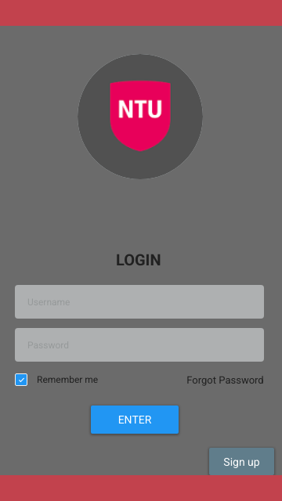
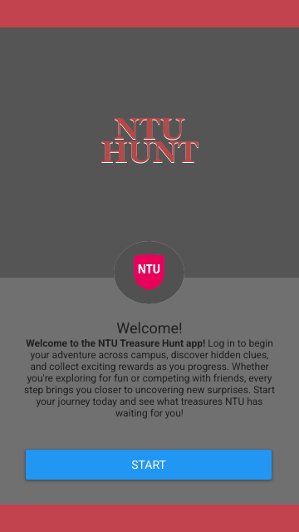
SCREEN 2 (LOGIN PAGE)
SCREEN 1 (WELCOME PAGE)

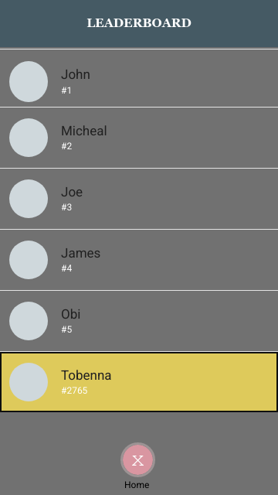
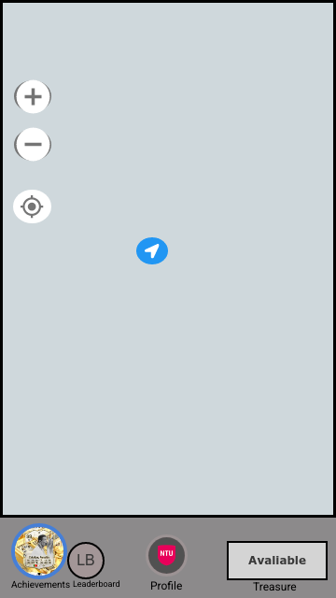
SCREEN 3 (LEADERBOARD)
SCREEN 4 (NAVIGATION HUB)

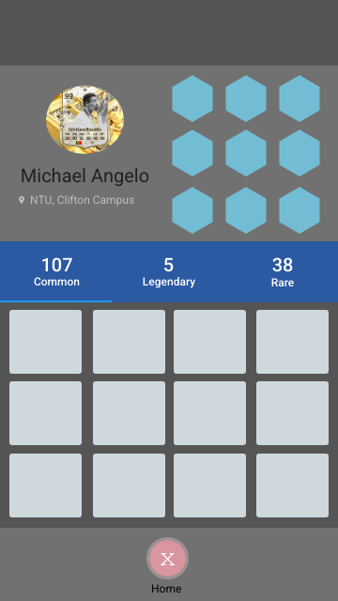
SCREEN 6 (STATS, ACHIEVEMENTS AND BADGES PAGE)
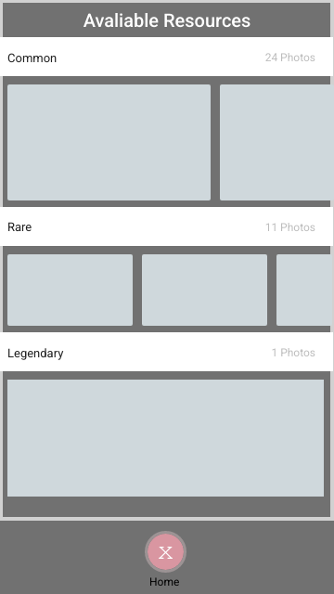
SCREEN 5 ( AVALIABLE TREASURE)

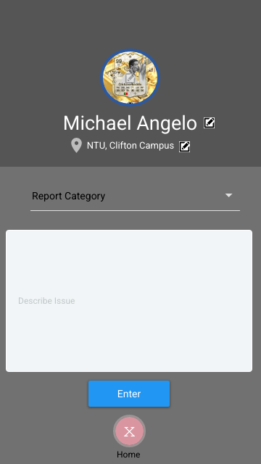
SCREEN 7 (SUPPORT PAGE)

Design guidelines justification
Screen 1 – Welcome Page
Design Guidelines Applied
- Simplicity & Minimalist Layout:
The welcome screen only displays the app title and a “Start” button, reducing cognitive load and ensuring new users are not overwhelmed.
- Brand Consistency:
NTU-inspired colours establish identity from the first interaction and maintain familiarity throughout the app.
- Large Tap Target for Primary Action:
The central button follows mobile-first guidelines by being large, easily tappable, and positioned in the middle for thumb access.
Justification: A simple, welcoming interface builds trust and supports a smooth onboarding experience.

Screen 2 – Login Page
Design Guidelines Applied
- Form Simplicity:
Only necessary fields are shown (NTU email and password). This prevents overload and reduces login friction.
- Clear Error Prevention:
Input boxes are separated and clearly labelled. This reduces the likelihood of entry mistakes and supports Nielsen’s “Error Prevention” heuristic.
- Visible Security Cues:
Requesting NTU email login clearly demonstrates the app’s authentication rules, supporting user trust.
- Consistent Button Styling:
“Login” button maintains the same style as the Welcome screen, reinforcing interface consistency.
Justification: A clean and secure login experience reassures users and supports accessibility standards.

Screen 3 – Leaderboard
Design Guidelines Applied
- Clear Visual Hierarchy:
Rankings and usernames are displayed in a card-like layout with bold numbers to make rank order immediately obvious.
- Familiar List Pattern:
Leaderboards commonly use vertical scrolling lists. Using this recognizable pattern aligns with Jakob’s Law.
- Contrast Between Places:
Use of spacing and line dividers improves readability and reduces visual clutter.
- Motivational Design (Gamification):
Performance ranking encourages continued use and aligns with behavioural engagement strategies.
Justification: The layout promotes quick understanding and encourages competition through clear ranking visuals.

Screen 4 – Navigation Hub
Design Guidelines Applied
- Icon-Based Navigation:
Large, simple icons represent features (Map, Treasures, Stats, Leaderboard, Support). Icons support accessibility and faster recognition than text alone.
- Thumb-Friendly Layout:
Navigation buttons are well spaced and positioned in the mid-to-lower screen area for comfortable hand use.
- Colour Consistency:
Uniform styling across icons maintains visual consistency and reduces cognitive load.
- Task-Oriented Design:
Users can immediately jump to their desired feature without navigating through layers of menus.
Justification: A centralized hub reduces confusion and follows mobile-first navigation principles, keeping the experience beginner-friendly.

Screen 5 – Available Treasure Page
Design Guidelines Applied
- Card-Based Layout:
Treasures are displayed as individual cards containing rarity, names, and icons. This follows Material Design guidelines and helps users process items quickly.
- Colour Coding by Rarity:
“Common”, “Rare”, and “Legendary” use distinct colour accents. This supports rapid scanning and motivates users to seek higher-value treasures.
- Map Integration Cue:
Each treasure card includes an icon or hint that reinforces the link between the treasure and physical campus location.
- Whitespace for Readability:
Clean spacing prevents the treasure list from feeling cluttered.
Justification: A structured list with meaningful colour signaling helps users navigate treasure options easily and efficiently.

Screen 6 – Stats, Achievements & Badges Page
Design Guidelines Applied
- Achievement Badging System:
Icons and badges use visual metaphors (shields, trophies, stars) which support recognition and reinforce gamification.
- Progress Feedback:
Completed vs. locked achievements follow a clear visual distinction (brightness or grayscale), aligning with the Visibility of System Status guideline.
- Consistent Card/Grid Layout:
Badges are arranged in a grid pattern making and comparison easy.
- Accessible Typography:
Labels beneath each icon are kept short and readable.
Justification: Visual feedback and rewarding imagery enhance motivation and help users track progress effortlessly.

Screen 7 – Support Page
Design Guidelines Applied
- Form Simplicity:
Only essential fields (issue description, category, contact info) are shown to reduce effort when reporting problems.
- Clear Call-to-Action:
The “Enter” button is large and visually distinct, ensuring users know how to complete the action.
- User Control:
Optional description details can be included, giving users freedom without forcing extra steps.
- Compliance with Accessibility Standards:
High-contrast form fields and readable text support users with visual impairments.
Justification: The support page is designed to be quick and frustration-free, encouraging students to report issues and improving the app’s long-term usability.

References

Gitnux (2025) Student Loneliness Statistics: Market Data Report 2025. Gitnux Market Data. Available at: https://gitnux.org (Accessed: 23 November 2025).

UK Government (2023) Research into Student Loneliness in Higher Education. Department for Education. Available at: https://www.gov.uk (Accessed: 23 November 2025).

Psychology Today (2024) Reducing Loneliness on College Campuses. Psychology Today. Available at: https://www.psychologytoday.com (Accessed: 23 November 2025).

Times Higher Education (2024) Digital Tools Empowering Modern Learners. Times Higher Education. Available at: https://www.timeshighereducation.com (Accessed: 23 November 2025).

eLearning Industry (2024) The Future of Education in the Digital Age Is Mobile-Centric. eLearning Industry. Available at: https://elearningindustry.com (Accessed: 23 November 2025).

Frontiers in Education (2023) Digital Learning in the 21st Century: Personalised and Accessible Experiences. Frontiers in Education. Available at: https://www.frontiersin.org (Accessed: 23 November 2025).

Pedagogy Journal (2023) Gamification in Universities: Students’ Satisfaction and Assurance of Learning. Pedagogy Journal. Available at: https://pedagogyjournal.com (Accessed: 23 November 2025).

TechTrends (2023) Gamification in Higher Education: A Case Study. TechTrends. Available at: https://springer.com/journal/11528 (Accessed: 23 November 2025).

Harvard Business School (2024) Boost Student Engagement: Effective Gamification Strategies. Harvard Business School Publishing. Available at: https://hbs.edu (Accessed: 23 November 2025).

Education Sciences (2023) From Engagement to Achievement: How Gamification Impacts Academic Success. Education Sciences. Available at: https://www.mdpi.com/journal/education (Accessed: 23 November 2025).

International Journal of STEM Education (2023) How Gamification Boosts Learning in STEM Higher Education. SpringerOpen. Available at: https://stemeducationjournal.springeropen.com (Accessed: 23 November 2025).

